> **with(DEtools):with(plots):**

> **f:=x->x^2-2*x;**



> **ec:=diff(x(t),t)=f(x(t));**



> **pct_ech:=solve(f(x)=0,x);**



> **pct_ech[1];**



> **D(f)(pct_ech[1]);**



> **D(f)(pct_ech[2]);**



> **DEplot(ec,x(t), t=-1/2..1/2, [[x(0)=-1],[x(0)=1],[x(0)=3],[x(0)=0],[x(0)=2]]);**

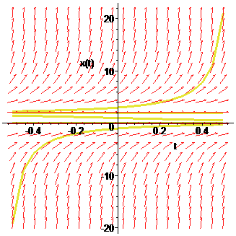



> **restart:**

> **with(DEtools):with(plots):**

Warning, the name changecoords has been redefined

> **f2:=x->x*(x-1)*(x-2);**



> **ec2:=diff(x(t),t)=f2(x(t));**



> **pct_ech2:=solve(f2(x)=0,x);**



> **D(f2)(pct_ech2[1]);**



> **D(f2)(pct_ech2[2]);**



> **D(f2)(pct_ech2[3]);**



> **DEplot(ec2,x(t), t=-1/10..1/10, [[x(0)=-1],[x(0)=1/2],[x(0)=3/2],[x(0)=3],[x(0)=0],[x(0)=1],[x(0)=2]]);**

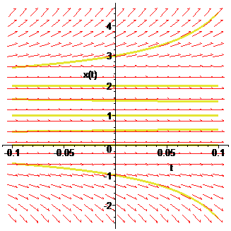

> **f3:=x->sin(x);**



> **ec3:=diff(x(t),t)=f3(x(t));**



> **_EnvAllSolutions := true:**

> **pct_ech3:=solve(f3(x)=0,x);**



> **D(f3)(pct_ech3[1]);**



> **DEplot(ec3,x(t), t=-7..7, [[x(0)=-Pi/2],[x(0)=-3*Pi/2],[x(0)=Pi],[x(0)=-Pi],[x(0)=0],[x(0)=-2*Pi]]);**

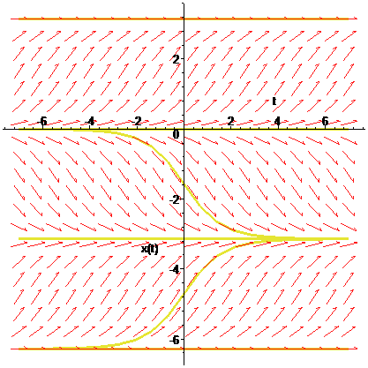

> **restart:**

>  **with(DEtools): with(plots):with(linalg):**

Warning, the name changecoords has been redefined

Warning, the name adjoint has been redefined

Warning, the protected names norm and trace have been redefined and unprotected

> **ec1:=diff(x(t),t)=2*x(t)+y(t);**



> **ec2:=diff(y(t),t)=x(t)+2*y(t);**



> **sist:=ec1,ec2;**



> **A:=matrix([[2,1],[1,2]]);**



>  **eigenvals(A);**



Error, (in DEtools/DEplot/CheckInitial) Invalid initial conditions - must be list of lists of conditions.

>  **DEplot([sist],[x(t),y(t)],t=-5..5,x=-6..6,y=-6..6, arrows=medium, linecolor=blue,stepsize=0.1);**

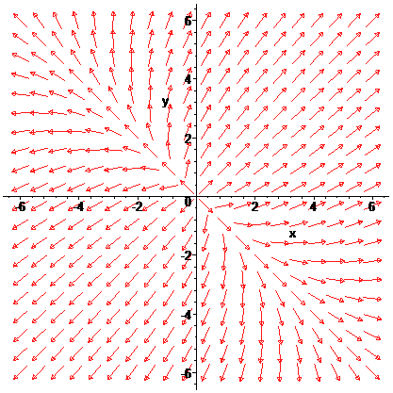

>

> **ec3:=diff(x(t),t)=-3*x(t)+4*y(t);**



> **ec4:=diff(y(t),t)=-2*x(t)+3*y(t);**



> **sist2:=ec3,ec4;**



> **B:=matrix([[-3,4],[-2,3]]);**



>  **eigenvals(B);**



>  **DEplot([sist2],[x(t),y(t)],t=-5..5,x=-6..6,y=-6..6, arrows=medium, linecolor=blue,stepsize=0.1);**

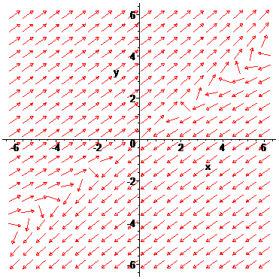

> **ec5:=diff(x(t),t)=-x(t)-y(t);**



> **ec6:=diff(y(t),t)=x(t)-3*y(t);**



> **sist3:=ec5,ec6;**



> **C:=matrix([[-1,-1],[1,-3]]);**



>  **eigenvals(C);**



>  **DEplot([sist3],[x(t),y(t)],t=-5..5,x=-6..6,y=-6..6, arrows=medium, linecolor=blue,stepsize=0.1);**

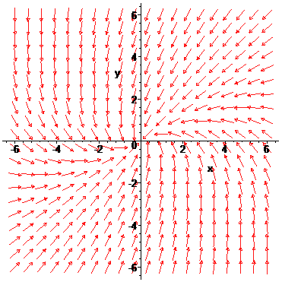

> **ec5:=diff(x(t),t)=-x(t)-y(t);**



> **ec6:=diff(y(t),t)=x(t)-3*y(t);**



> **sist3:=ec5,ec6;**



> **C:=matrix([[-1,-1],[1,-3]]);**



>  **eigenvals(C);**



>  **DEplot([sist3],[x(t),y(t)],t=-5..5,x=-6..6,y=-6..6, arrows=medium, linecolor=blue,stepsize=0.1);**



> **ec7:=diff(x(t),t)=-2*x(t);**



> **ec8:=diff(y(t),t)=-4*x(t)-2*y(t);**



> **sist4:=ec7,ec8;**



> **E:=matrix([[-2,0],[-4,-2]]);**



>  **eigenvals(E);**



>  **DEplot([sist4],[x(t),y(t)],t=-5..5,x=-6..6,y=-6..6, arrows=medium, linecolor=blue,stepsize=0.1);**

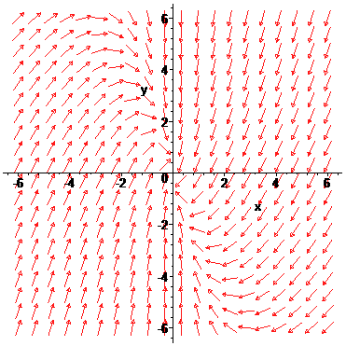

> **ec9:=diff(x(t),t)=x(t)+4*y(t);**



> **ec10:=diff(y(t),t)=x(t)+y(t);**



> **sist5:=ec9,ec10;**



> **F:=matrix([[1,4],[1,1]]);**



>  **eigenvals(F);**



>  **DEplot([sist5],[x(t),y(t)],t=-5..5,x=-6..6,y=-6..6, arrows=medium, linecolor=blue,stepsize=0.1);**

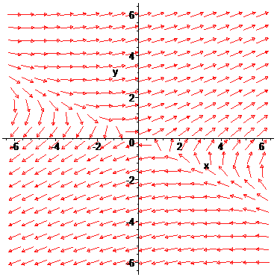

> **ec11:=diff(x(t),t)=2*x(t)-y(t);**



> **ec12:=diff(y(t),t)=x(t)+2*y(t);**



> **sist6:=ec11,ec12;**



> **G:=matrix([[2,-1],[1,2]]);**



>  **eigenvals(G);**



>  **DEplot([sist6],[x(t),y(t)],t=-5..5,x=-6..6,y=-6..6, arrows=medium, linecolor=blue,stepsize=0.1);**

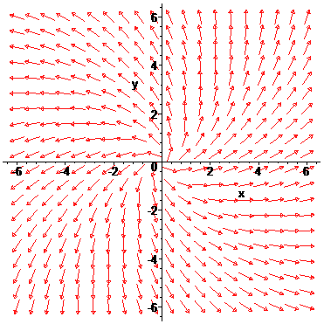

> **ec13:=diff(x(t),t)=-y(t);**



> **ec14:=diff(y(t),t)=x(t);**



> **sist7:=ec13,ec14;**



> **H:=matrix([[0,-1],[1,0]]);**



>  **eigenvals(H);**



>  **DEplot([sist7],[x(t),y(t)],t=-5..5,x=-6..6,y=-6..6, arrows=medium, linecolor=blue,stepsize=0.1);**

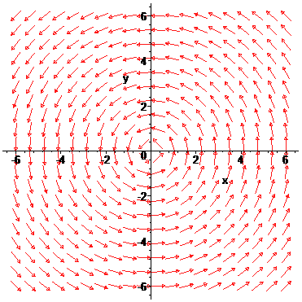

> **ec15:=diff(x(t),t)=x(t)-4*y(t);**



> **ec16:=diff(y(t),t)=5*x(t)-3*y(t);**



> **sist8:=ec15,ec16;**



> **K:=matrix([[1,-4],[5,-3]]);**



>  **eigenvals(K);**



>  **DEplot([sist8],[x(t),y(t)],t=-5..5,x=-6..6,y=-6..6, arrows=medium, linecolor=blue,stepsize=0.1);**

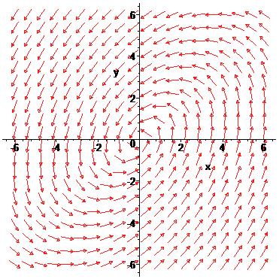

> **restart:**

>  **with(DEtools): with(plots):with(linalg):**

Warning, the name changecoords has been redefined

Warning, the name adjoint has been redefined

Warning, the protected names norm and trace have been redefined and unprotected

> **f1:=(x,y)->y;**



> **f2:=(x,y)->x*(1-x^2)+y;**



>  **ec1:=diff(x(t),t)=f1(x(t),y(t));**



>  **ec2:=diff(y(t),t)=f2(x(t),y(t));**



> **sist1:=ec1,ec2;**



> **pct_ech1:=solve({f1(x,y)=0,f2(x,y)=0},{x,y});**



> **pct_ech1[1,1];pct_ech1[1,2];**





>  **J:=jacobian([f1(x,y),f2(x,y)],[x,y]);**



>  **A1:=subs(pct_ech1[1,1],pct_ech1[1,2],eval(J));**



>  **eigenvals(A1);**



>  **A2:=subs(pct_ech1[2,1],pct_ech1[2,2],eval(J));**



>  **eigenvals(A2);**



> **A3:=subs(pct_ech1[3,1],pct_ech1[3,2],eval(J));**



> **eigenvals(A3);**



> **condin:=[x(0)=-1,y(0)=1],[x(0)=-0.5,y(0)=1],[x(0)=1,y(0)=1],[x (0)=1,y(0)=3],[x(0)=2,y(0)=0.5],[x(0)=-1,y(0)=-1],[x(0)=-0.5,y (0)=-1],[x(0)=-1,y(0)=-2.5],[x(0)=1,y(0)=-1],[x(0)=1.5,y(0)=-1 ],[x(0)=1,y(0)=-2.5];**



>  **DEplot([sist1],[x(t),y(t)],t=-10..10,x=-3..3,y=-3..3, [condin],linecolor=blue,stepsize=0.1);**

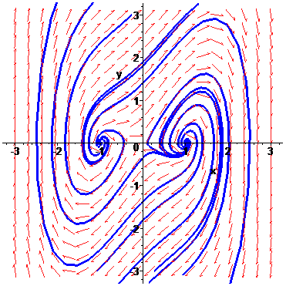

> **f3:=(x,y)->-2*x+y+2;**



> **f4:=(x,y)->x*y;**



>  **ec3:=diff(x(t),t)=f3(x(t),y(t));**



>  **ec4:=diff(y(t),t)=f4(x(t),y(t));**



> **sist2:=ec3,ec4;**



> **pct_ech2:=solve({f3(x,y)=0,f4(x,y)=0},{x,y});**



> **pct_ech2[1,1];pct_ech2[1,2];**





>  **J:=jacobian([f3(x,y),f4(x,y)],[x,y]);**



>  **A1:=subs(pct_ech2[1,1],pct_ech2[1,2],eval(J));**



>  **eigenvals(A1);**



>  **A2:=subs(pct_ech2[2,1],pct_ech2[2,2],eval(J));**



>  **eigenvals(A2);**



> **condin:=[x(0)=-1,y(0)=1],[x(0)=-0.5,y(0)=1],[x(0)=1,y(0)=1],[x (0)=1,y(0)=3],[x(0)=2,y(0)=0.5],[x(0)=-1,y(0)=-1],[x(0)=-0.5,y (0)=-1],[x(0)=-1,y(0)=-2.5],[x(0)=1,y(0)=-1],[x(0)=1.5,y(0)=-1 ],[x(0)=1,y(0)=-2.5];**



>  **DEplot([sist2],[x(t),y(t)],t=-10..10,x=-3..3,y=-3..3, [condin],linecolor=blue,stepsize=0.1);**

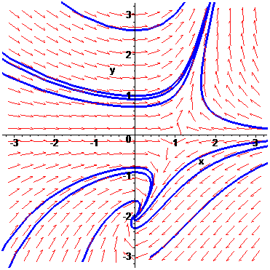

> **f5:=(x,y)->y^2;**



> **f6:=(x,y)->x;**



> **ec5:=diff(x(t),t)=f5(x(t),y(t));**



> **ec6:=diff(y(t),t)=f6(x(t),y(t));**



> **sist3:=ec5,ec6;**



> **pct_ech3:=solve({f5(x,y)=0,f6(x,y)=0},{x,y});**



> **pct_ech3[1,1];pct_ech3[1,2];\**





>  **J:=jacobian([f5(x,y),f6(x,y)],[x,y]);**



>  **A1:=subs(pct_ech3[1,1],pct_ech3[1,2],eval(J));**



>  **eigenvals(A1);**



> **condin:=[x(0)=-1,y(0)=1],[x(0)=-0.5,y(0)=1],[x(0)=1,y(0)=1],[x (0)=1,y(0)=3],[x(0)=2,y(0)=0.5],[x(0)=-1,y(0)=-1],[x(0)=-0.5,y (0)=-1],[x(0)=-1,y(0)=-2.5],[x(0)=1,y(0)=-1],[x(0)=1.5,y(0)=-1 ],[x(0)=1,y(0)=-2.5];**



>  **DEplot([sist3],[x(t),y(t)],t=-10..10,x=-3..3,y=-3..3, [condin],linecolor=blue,stepsize=0.1);**

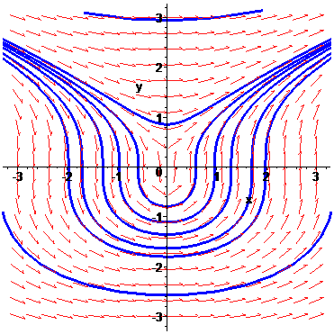

> **f7:=(x,y)->x^2-y^2;**



> **f8:=(x,y)->x*y-1;**



> **ec7:=diff(x(t),t)=f7(x(t),y(t));**



> **ec8:=diff(y(t),t)=f8(x(t),y(t));**



> **sist4:=ec7,ec8;**



> **pct_ech4:=solve({f7(x,y)=0,f8(x,y)=0},{x,y});**



> **pct_ech4[1,1];pct_ech4[1,2];**





>  **J:=jacobian([f7(x,y),f8(x,y)],[x,y]);**



>  **A1:=subs(pct_ech4[1,1],pct_ech4[1,2],eval(J));**



>  **eigenvals(A1);**



>  **A2:=subs(pct_ech4[2,1],pct_ech4[2,2],eval(J));**



>  **eigenvals(A2);**



>

>